# 

**Madhurya Mozumder**

**RA1911028010036**

**CSE-CC**

**I2**

# **Ex.No-7 FULL DUPLEX CHAT USING TCP**

**AIM:** To implement Full-Duplex chat using TCP client-server.

**Server.c**

**#include<sys/types.h>**

**#include<sys/socket.h>**

**#include<stdio.h>**

**#include<unistd.h>**

**#include<netdb.h>**

**#include<arpa/inet.h>**

**#include<netinet/in.h>**

**#include<string.h>**

**int main(int argc,char *argv[])**

**{**

**int clientSocketDescriptor,socketDescriptor;**

**struct sockaddr_in serverAddress,clientAddress;**

**socklen_t clientLength;**

**char recvBuffer[1000],sendBuffer[1000];**

**pid_t cpid;**

**bzero(&serverAddress,sizeof(serverAddress));**

**/*Socket address structure*/**

**serverAddress.sin_family=AF_INET;**

**serverAddress.sin_addr.s_addr=htonl(INADDR_ANY);**

**serverAddress.sin_port=htons(6601);**

**/*TCP socket is created, an Internet socket address structure is filled with**

**wildcard address & server’s well known port*/**

**socketDescriptor=socket(AF_INET,SOCK_STREAM,0);**

**/*Bind function assigns a local protocol address to the socket*/**

**bind(socketDescriptor,(struct sockaddr*)&serverAddress,sizeof(serverAddress));**

**/*Listen function specifies the maximum number of connections that kernel should queue**

**for this socket*/**

**listen(socketDescriptor,5);**

**printf("%s\n","Server is running ...");**

**/*The server to return the next completed connection from the front of the**

**completed connection Queue calls it*/**

**clientSocketDescriptor=accept(socketDescriptor,(struct sockaddr*)&clientAddress,&clientLength);**

**/*Fork system call is used to create a new process*/**

**cpid=fork();**

**if(cpid==0)**

**{**

**while(1)**

**{**

**bzero(&recvBuffer,sizeof(recvBuffer));**

**/*Receiving the request from client*/**

**recv(clientSocketDescriptor,recvBuffer,sizeof(recvBuffer),0);**

**printf("\nCLIENT : %s\n",recvBuffer);**

**}**

**}**

**else**

**{**

**while(1)**

**{**

**bzero(&sendBuffer,sizeof(sendBuffer));**

**printf("\nType a message here ... ");**

**/*Read the message from client*/**

**fgets(sendBuffer,10000,stdin);**

**/*Sends the message to client*/**

**send(clientSocketDescriptor,sendBuffer,strlen(sendBuffer)+1,0);**

**printf("\nMessage sent !\n");**

**}**

**}**

**return 0;**

**}**

**Client.c**

**#include "stdio.h"**

**#include "stdlib.h"**

**#include "string.h"**

**//headers for socket and related functions**

**#include <sys/types.h>**

**#include <sys/socket.h>**

**//for including structures which will store information needed**

**#include <netinet/in.h>**

**#include <unistd.h>**

**//for gethostbyname**

**#include "netdb.h"**

**#include "arpa/inet.h"**

**int main()**

**{**

**int socketDescriptor;**

**struct sockaddr_in serverAddress;**

**char sendBuffer[1000],recvBuffer[1000];**

**pid_t cpid;**

**bzero(&serverAddress,sizeof(serverAddress));**

**serverAddress.sin_family=AF_INET;**

**serverAddress.sin_addr.s_addr=inet_addr("127.0.0.1");**

**serverAddress.sin_port=htons(6601);**

**/*Creating a socket, assigning IP address and port number for that socket*/**

**socketDescriptor=socket(AF_INET,SOCK_STREAM,0);**

**/*Connect establishes connection with the server using server IP address*/**

**connect(socketDescriptor,(struct sockaddr*)&serverAddress,sizeof(serverAddress));**

**/*Fork is used to create a new process*/**

**cpid=fork();**

**if(cpid==0)**

**{**

**while(1)**

**{**

**bzero(&sendBuffer,sizeof(sendBuffer));**

**printf("\nType a message here ... ");**

**/*This function is used to read from server*/**

**fgets(sendBuffer,10000,stdin);**

**/*Send the message to server*/**

**send(socketDescriptor,sendBuffer,strlen(sendBuffer)+1,0);**

**printf("\nMessage sent !\n");**

**}**

**}**

**else**

**{**

**while(1)**

**{**

**bzero(&recvBuffer,sizeof(recvBuffer));**

**/*Receive the message from server*/**

**recv(socketDescriptor,recvBuffer,sizeof(recvBuffer),0);**

**printf("\nSERVER : %s\n",recvBuffer);**

**}**

**}**

**return 0;**

**}**

**OUTPUT:**

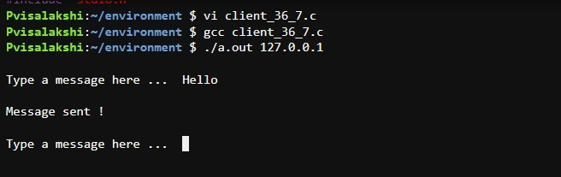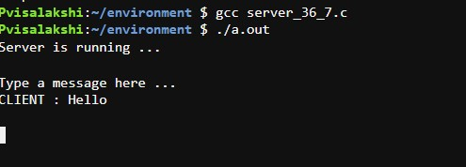

**RESULT:** Full-Duplex chat using TCP client-server is successfully implemented.